1. Frank Pepe Pizzeria Napoletana

Address – 157 Wooster St, New Haven, CT 06511

|  |  |
| --- | --- |
| Mon - Thu | Closed |
| Fri: | 5:00 pm - 9:00 pm |
| Sat: | 1:00 pm - 11:30 pm |
| Sun: | 1:00 pm - 10:00 pm |
|  |  |

* Photos

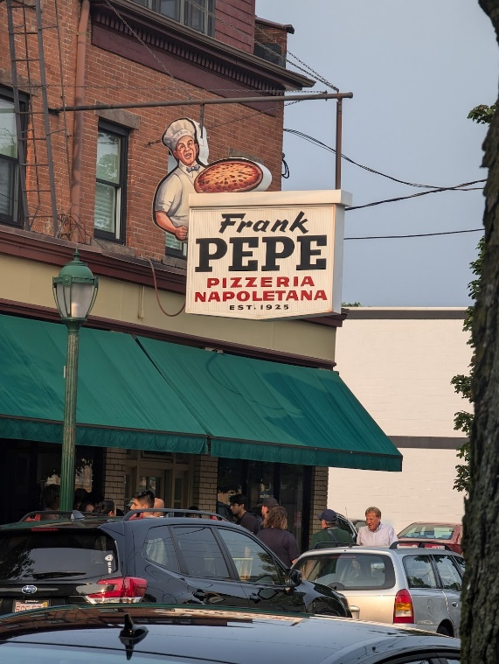 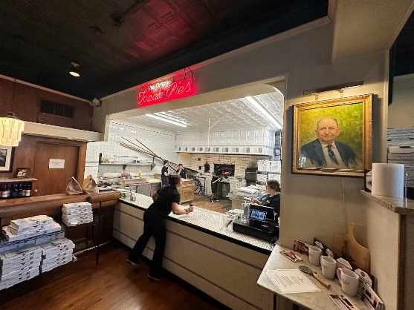

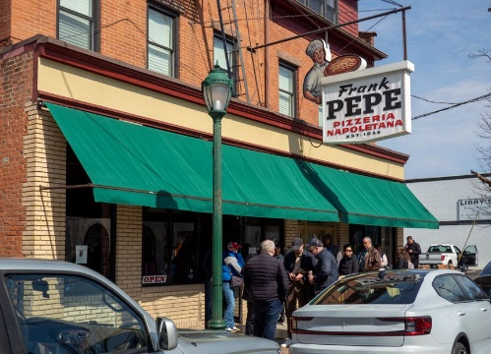 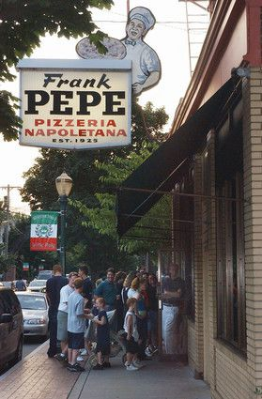

* Established – 1925
* Home to white clam pizza
* Locally known as Pepeâ??s (pep-eez)
* its Original Location in the Wooster Square neighborhood of New Haven, CT. Today, there are 14 additional locations across CT, MA, RI, NY, MD, VA, and FL
* Website details
* Currently not reachable (**www.pepespizza.com** took too long to respond.)

1. Modern Apizza

Address - 874 State St, New Haven, CT

|  |  |
| --- | --- |
| Mon | Closed |
| Tue - Thu: | 11:00 am - 11:00 pm |
| Fri - Sat: | 11:00 am - 11:30 pm |
| Sun: | 3:00 pm - 10:00 pm |

* Photos

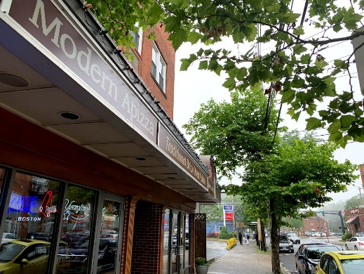 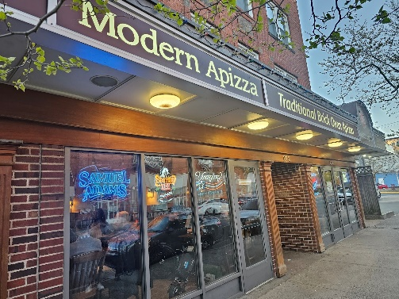

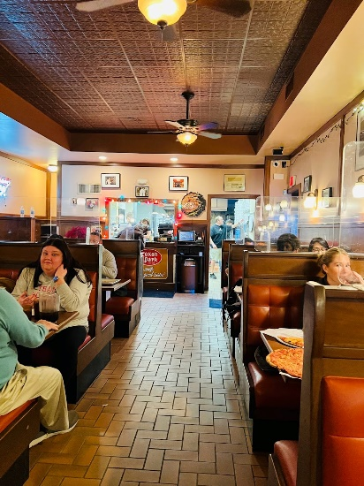 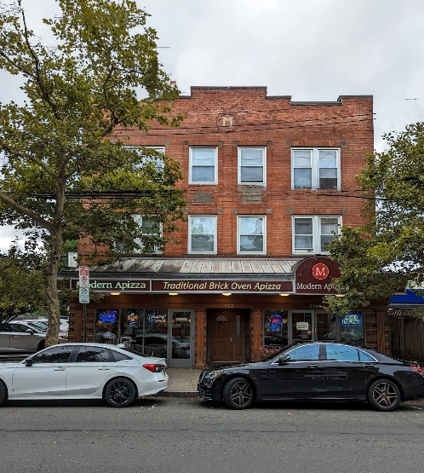

* Established – 1925
* serves traditional brick-oven pizzas, with mozzarella and American cheese bases
* Also Known as PizzaPlus
* History
* On March 4, 1911, Antonio “Tony” Tolli was born in Plainville
* then returning to America at age 18
* In 1934, Joseph Marzullo and his cousin, Antonio ToIli, opened a pizzeria down the street from Marzullo’s confectionery and called it Washington Pizzeria
* They lasted in business here for two years when Marzullo returned to his pastry shop.
* Website Detail – ( <https://www.modernapizza.com/> )
* Single page website Contains Opening hour, address, Menu and Certificates
* UI can be Improved
* Buy certificates features ( Payment Gateway )
* Website Detail – ( <https://www.pizzaplusinc.com/> )
* Single page website Contains Opening hour, address, Menu and Certificates
* Order Online features ( Payment Gateway )
* Old UI
* Application form for job, feedback

1. Marco Polo Pizzeria & Italian Restaurant

**Address - 55 Crown Street**, **New Haven, CT 06510**

|  |  |
| --- | --- |
| Mon - Sat: | 10:00 am - 11:30 pm |
| Sun: | 11:00 am - 11:30 pm |

* Booking for Catering
* Italian food
* Corporate Meetings
* Birthday Parties
* Anniversaries
* Baby / Bridal Showers
* Graduations
* Corporate Lunches & Picnics
* Holiday Parties
* School Events
* Photos

